PROGRAMMING FUNDAMENTAL LAB 3

TASK 1:

Click: <https://github.com/Hanya321/Unordered-List--Markdown/blob/main/README.md>

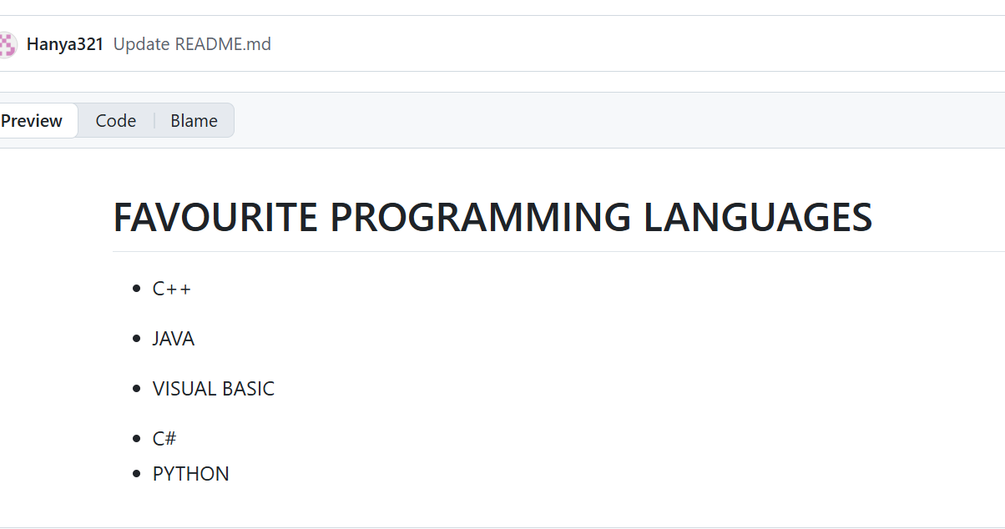

TASK 2:

Click: <https://github.com/Hanya321/Task-5/blob/my-first-branch/PROFILE>

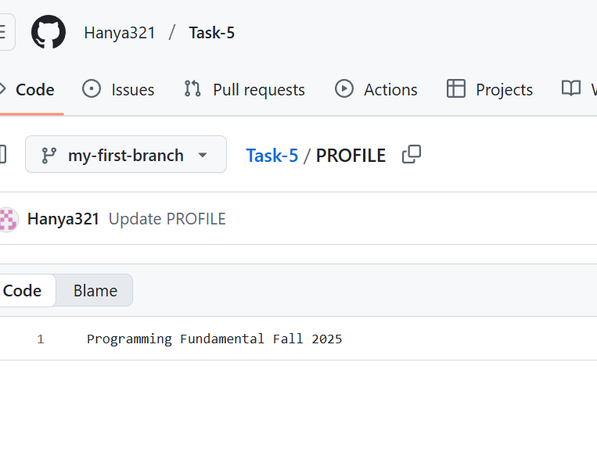

TASK 3:

Click:<https://github.com/Hanya321/PROFILE/blob/main/README.md>

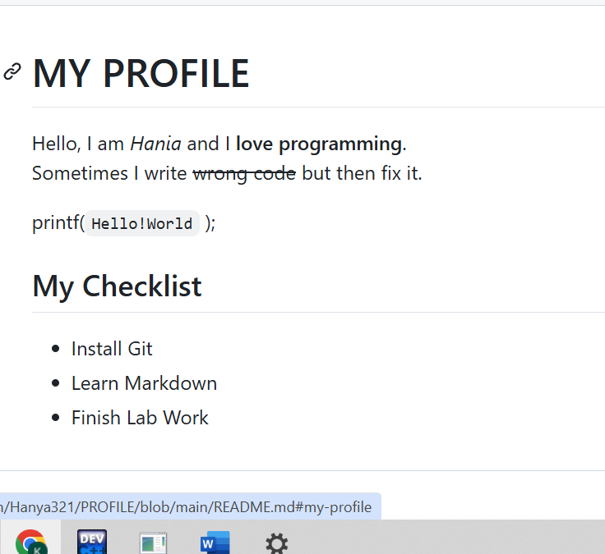

TASK 4:

|  |
| --- |
| #include<stdio.h>  int main()  {int age;  float height;  printf("Enter your age:");  scanf("%d",&age);  printf("Enter you height:");  scanf("%f",&height);  printf("Age=%d\nHeight=%.2f",age,height);  return 0;  } |

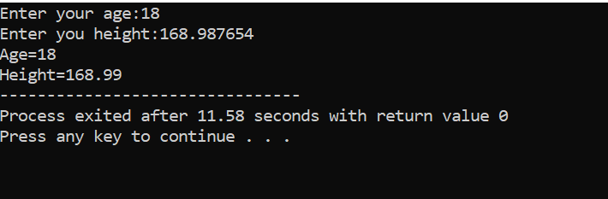

TASK 5:

|  |
| --- |
| #include<stdio.h>  int main()  {printf("Hello!\nHow are you\?\nShe said:\"Hi\\\"");  return 0;  } |

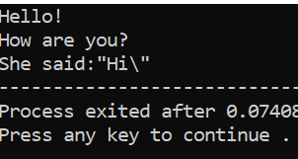

TASK 6:

|  |
| --- |
| #include<stdio.h>  int main()  {int birth_year,current_year;  printf("Enter your current year:");  scanf("%d",&current_year);  printf("Enter your birth year:");  scanf("%d",&birth_year);  printf("Age=%d",current_year-birth_year);  return 0;  } |

